Voyage_Vists_Illuminating_Insights_from_Uber_Expeditionary_Analysis

Introduction:

Project description:

Uber is a multinational transportation network company that operates a ride-hailing platform. It was founded in 2009 by Garrett Camp and Travis Kalanick and is based in San Francisco, California. Uber provides a convenient way for individuals to request rides from drivers who use their own personal vehicles. Uber Driver Analysis refers to the Analyzing the number of trips taken by Uber drivers can provide insights into their overall activity and the demand for rides in specific areas. Daily, Weekly, or Monthly Analysis: Uber's data can be analyzed on a daily, weekly, monthly basis to understand the trends and patterns of trip volumes. This analysis can help identify peak hours or days of high demand and optimize driver availability during those times. Trips can be analyzed based on geographic regions or specific cities to identify areas with higher demand. This analysis can help Uber drivers decide where to focus their driving efforts for maximum efficiency and profitability. The Major of our project is to use data Analyzing techniques to find unknown patterns in the Uber Drives dataset. The research is carried out on Uber drives data collected from the year 2016.

Purpose:

The purpose of Uber trips can vary widely and is determined by the needs of individual passengers. Some common reasons people use Uber include commuting to work, running errands, going out for social events, traveling to the airport, or simply getting from one place to another when they don't have access to their own vehicle. Uber serves as a convenient and flexible transportation option for many different purposes. Trip Radar is a new feature that gives you and other drivers a chance to see and show interest in all products requests happening nearby. Trip Radar shows you extra options, and you'll continue to get individual requests, too. We are a tech company that connects the physical and digital worlds to help make movement happen at the tap of a button. Because we believe in a world where movement should be accessible. So you can move and earn safely.

Problem defining and design thinking:

Empathy map:

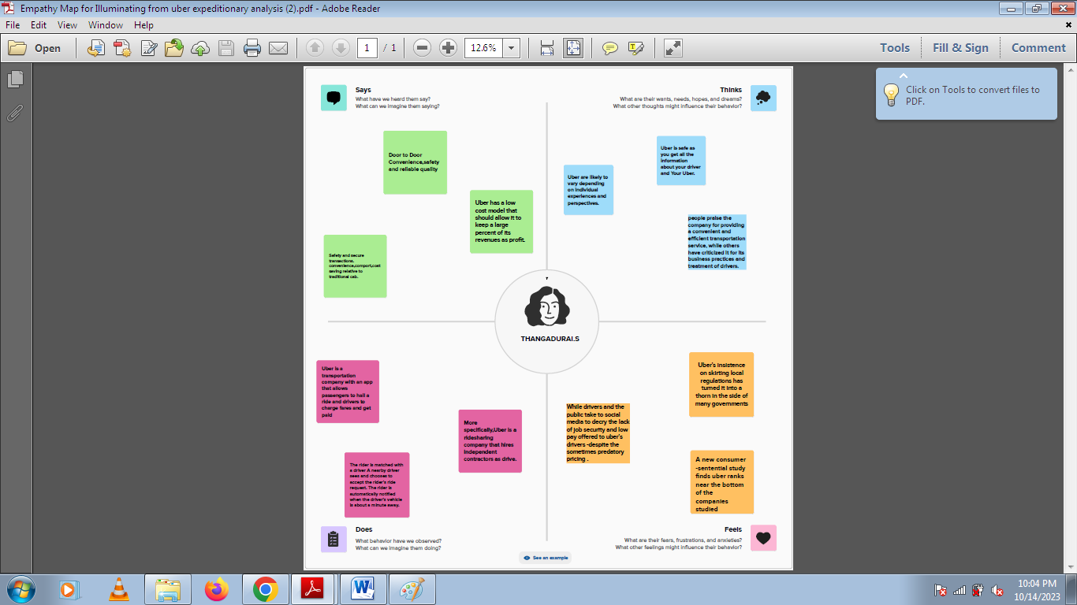

Brainstorming map:

## r

## r

**result:**

## Dashboard :

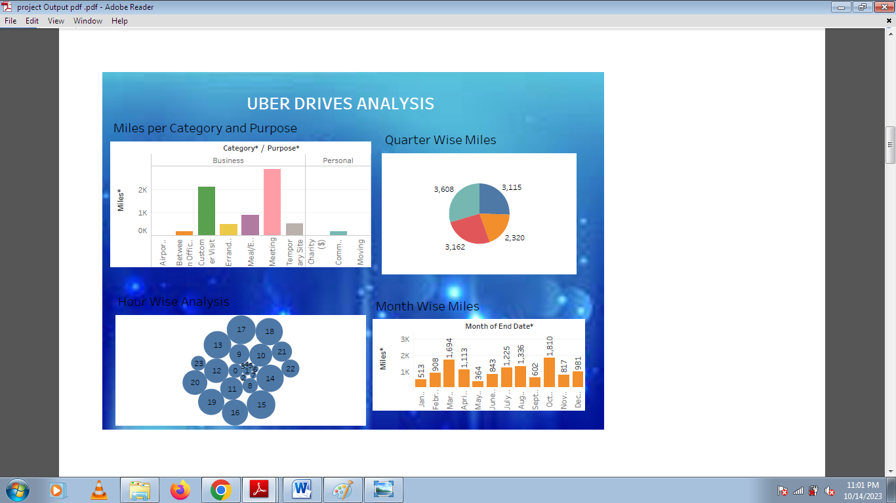

## story:

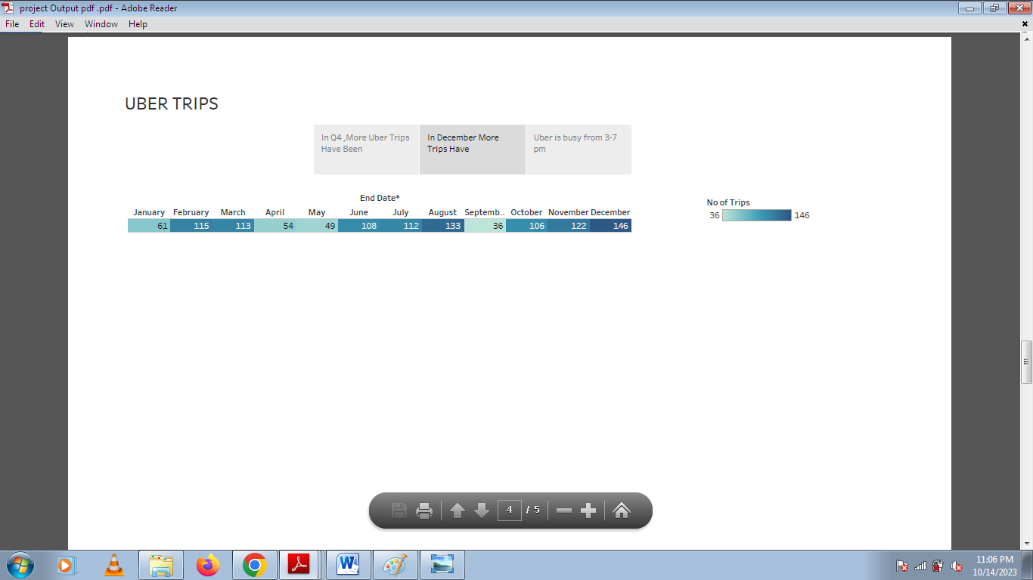

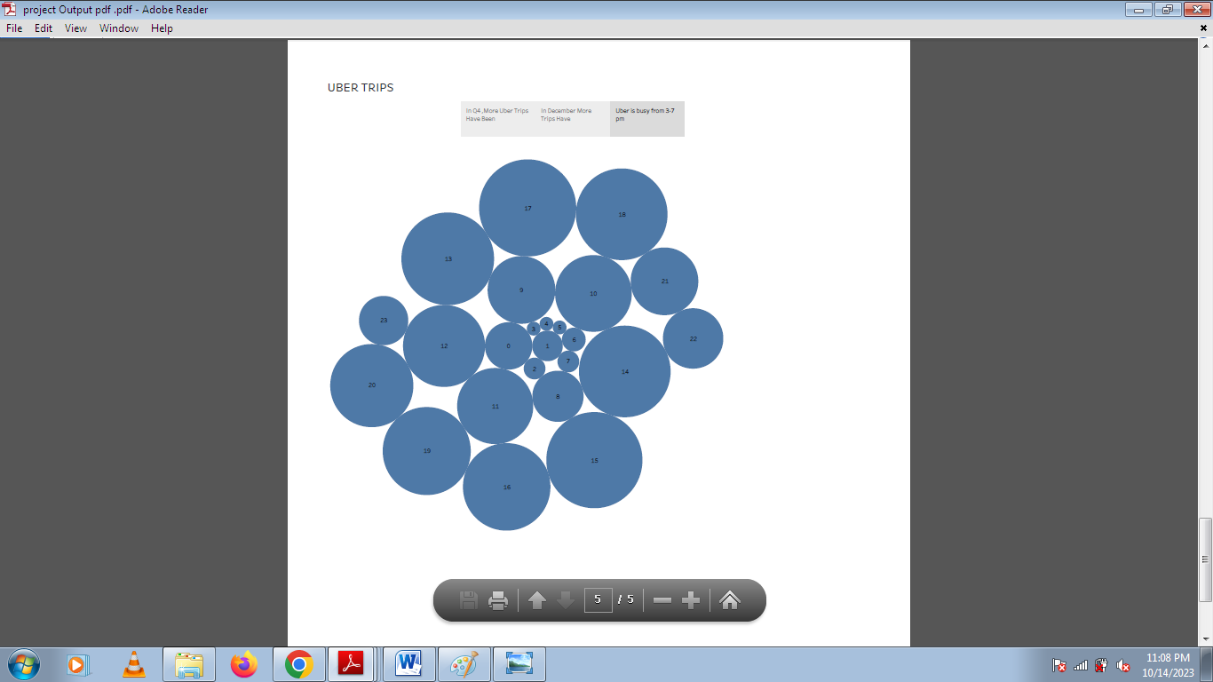

Advantages :

Convenience:

* Uber provides a convenient way to book rides with just a few taps on your smartphone. You can schedule rides in advance or request one on-demand.

Safety:

* Uber drivers undergo background checks, and you can track your ride in real-time, enhancing safety for both passengers and drivers.

Cost-Efficiency:

* Uber can be more cost-effective than owning and maintaining a car, especially in urban areas where parking and fuel costs are high.

Accessibility:

* Uber is available in many cities worldwide, making it easy to find a ride almost anywhere.

Range of Options:

* Uber offers different service tiers, including UberX, Uber Black, and Uber Pool, catering to various preferences and budgets.

Cashless Payments:

* Payment is made through the app, so you don't need to carry cash. You can also split fares with friends.

Ratings and Reviews:

* Both drivers and passengers can rate each other, promoting accountability and good behavior.

Environmental Benefits:

* Ridesharing services like Uber can reduce the number of cars on the road, leading to potential environmental benefits.

Flexibility:

* For drivers, Uber offers flexible earning opportunities, allowing people to work on their terms.

Enhanced GPS Navigation:

* Uber uses advanced GPS technology for efficient route planning, reducing travel time.

Disadvantages:

Surge Pricing:

* During peak times or high demand, Uber may implement surge pricing, which can significantly increase the cost of a ride.

Safety Concerns:

* Safety can be a concern, as both riders and drivers may face risks when interacting with strangers.

Price Variability:

* Uber fares can vary widely based on factors such as distance, time of day, and location, making it difficult to predict the exact cost of a trip.

Limited Coverage:

* Uber may not be available in all areas, especially in rural or less densely populated regions.

Dependence on Technology:

* Uber relies on the availability of smartphones and the Uber app, which may exclude some potential riders.

Quality of Service:

* The quality of service can vary among drivers, which may lead to inconsistent experiences for riders.

Regulatory Issues:

* Uber has faced legal and regulatory challenges in some regions, leading to potential service interruptions or restrictions.

Environmental Impact:

* Uber rides can contribute to increased traffic congestion and emissions, especially if there is a high volume of trips in a particular area.

Applications:

Transportation:

* The primary application of Uber is to provide convenient, on-demand transportation for individuals. Whether it's commuting to work, running errands, or going out for social events, Uber offers a flexible and accessible mode of travel.

Airport Transportation:

* Many people use Uber for rides to and from airports, offering a reliable alternative to traditional taxi services.

Late-Night Transportation:

* Uber is often used as a safe and convenient way to get home after a night out when other transportation options might be limited.

Business Travel:

* Business travelers frequently use Uber for transportation, as it allows for easy expense tracking and a convenient way to get around in unfamiliar cities.

Ridesharing and Carpooling:

* Uber offers services like UberPOOL, which allows riders to share trips with others going in the same direction, reducing costs and environmental impact.

Food Delivery:

* In addition to transporting people, Uber also provides food delivery services through Uber Eats, allowing users to order food from local restaurants and have it delivered to their doorstep.

Grocery and Retail Shopping:

* Some regions offer Uber Connect and Uber Direct services for parcel and grocery delivery, providing an alternative to traditional courier services.

Medical Transportation:

* Uber Health provides transportation solutions for healthcare providers to arrange non-emergency medical transportation for patients.

Rural and Underserved Areas:

* In some areas, Uber serves as a more reliable transportation option in locations where traditional taxi services may be scarce.

Events and Festivals:

* Uber is often used to travel to and from events, concerts, and festivals, providing a convenient way for attendees to get around without

worrying about parking.

Tourism

* Tourists use Uber as a convenient way to explore a new city or destination, often eliminating the need to rent a car.

Conclusion:

Uber trips serve a wide range of purposes, from daily commuting to leisure travel. The future scope for Uber trips is promising, with potential developments in electric and autonomous vehicles, expanded micro-mobility options, integration with public transportation, and a focus on sustainability. Uber's presence may grow in rural and emerging markets, and the company is likely to continue its ventures into delivery services. Enhanced safety and security measures, data-driven personalization, and adaptation to changing regulations will shape the evolution of Uber's services in the years to come. Visit the Activity section of your Uber app to view your complete Uber history (including Uber Eats orders) and save receipts for each trip. Select a trip to view additional details and submit a report as needed. Courteous and cordial with dedication to maintaining safe driving record. Dedicated and responsible Industry professional with excellent sales and service abilities. Knowledgeable about Product or Service promotions and able to develop deep customer connections to promote sustained revenue. Uber Technologies, Inc. (commonly referred to as Uber) provides ride-hailing services, food delivery, and freight transport. It is headquartered in San Francisco and operates in approximately 70 countries and 10,500 cities worldwide.

Future scope:

Electric and Autonomous Vehicles:

* Uber is investing in electric and autonomous vehicle technologies. In the future, you may see more electric and self-driving cars, which could make trips more eco-friendly and cost-effective.

Micro-Mobility:

* Uber has expanded into bike and scooter rentals. This might continue to grow, especially in urban areas, as people seek alternative, eco-friendly transportation options for short trips.

Integration with Public Transportation:

* Uber may integrate with public transportation systems more seamlessly, offering multi-modal transportation options that combine ridesharing with buses, trains, and other forms of transit.

Rural and Emerging Markets:

* Uber may expand its services to more rural and emerging markets, providing transportation solutions to areas that currently have limited access.

Delivery Services:

* Uber Eats and Uber Freight are examples of Uber's venture into delivery services. The company may continue to expand its presence in the delivery space, catering to the growing demand for food and package delivery.

Sustainability Initiatives:

* As environmental concerns grow, Uber is likely to adopt more sustainability initiatives, promoting electric vehicles, reducing emissions, and minimizing its carbon footprint.

New Mobility Models:

* Uber might experiment with new mobility models, such as air taxis or other innovative forms of transportation as technology advances.

Enhanced Safety and Security:

* Expect Uber to continue focusing on improving passenger and driver safety with advanced technology, like real-time identity verification and emergency features.

Data and Personalization:

* Uber may use data and AI to personalize rides and services, offering passengers tailored experiences and more accurate pick-up and drop-off predictions.

Regulatory Changes:

* The future scope will also depend on regulatory changes and public acceptance of new technologies and services. Uber will need to adapt to evolving legal and cultural landscapes.

Thank you